SUPPLEMENTARY MATERIAL:

Are language deficits associated with psychosis risk universal? Automated analyses of spoken language in Mandarin-speaking youths at clinical high risk for psychosis, by Agurto et al.
Carla Agurto, Raquel Norel, Bo Wen, Yanyan Wei, Dan Zhang, Zarina Bilgrami, Xiaolu His, Tianhong Zhang, Ofer Pasternak, Huijun Li, Matcheri Keshavan, Larry J. Seidman, Susan Whitfield-Gabrieli, Martha E. Shenton, Margaret A. Niznikiewicz, Jijun Wang, Guillermo Cecchi, Cheryl M. Corcoran, William S. stone.
In press, World Psychiatry
Subjects

Supplementary Table 1. Demographics and clinical variables of the cohorts.
 | Category | CHR |  |  | Healthy Controls | Statistics
Demographics | Sex |  | 20 (11 females) |  | 25 (12 females) | Chi-Square: 0.22, p=0.64
Demographics | Age |  | 19.6 +/- 6.4 |  | 24.9 +/- 1.9 | KS-test: 0.75, p=1E-6
Demographics | Race |  | 100% Chinese |  | 100% Chinese | --
Demographics | Education in years |  | 11.4 +/- 4.0 |  | 16.7 +/- 1.4 | KS-test: 0.7, p=1E-5
SIPS/SOPS  scores | Negative Symptoms |  | 10.2 +/- 5.4 | -- |  | --
SIPS/SOPS  scores | Positive Symptoms |  | 9.1 +/- 4.0 | -- |  | --

Supplementary Methods
Preprocessing
To analyze only the speech of the subjects, we needed to identify and extract the parts of their voice from the whole interview since only one channel was used in the recording. Given that manual transcription contained the timestamps that indicate when the subject is speaking, we used that information to segment the recording and then join only subject’s segments to generate a new audio file.
Metrics
Acoustic features: Based on the literature as well as our previous work on the characterization of CHR subjects^{1,2,3,4}, we extracted several features that can capture flattened intonation, disturbed flow of speech (e.g., voice break), changes in speech rate and other characteristics found in studies that characterize speech in schizophrenia patients. All these features were extracted in the pre-processed audio containing only the subject’s speech in Mandarin. We grouped all the extracted features in 8 categories: pitch variations, changes in rhythm, voice stability, spectral characterization, vowel space, MFCCs, chroma features, and noise measurements (see Table 2). More information about the processing used to compute these features can be found here⁴⁻⁶.
English-based linguistic features: To perform a thorough characterization of the content of the subject’s speech, we extracted features at the word, sentence, and paragraph level. To do so, we prepared the text to be analyzed by tokenizing and lemmatizing it using the NLTK library¹⁶. In addition, we only kept the content words of the text by removing the stop words (e.g., “then”) from our analysis, using the provided list from natural language toolkit library in python (NLTK)⁷.
At the word level, we used part of speech (PoS) tagging⁸ to obtain the normalized frequency (percentage) of different parts of speech such as adjectives, verbs, etc. used by the subject during the interview (see Table 2). We also quantified content and unique words normalized by the total number of words uttered by the subject.
In the case of features extracted at the sentence level, we used two categories: graph-based and speech coherence. For graph-based features, each word (previously lemmatized) becomes a graph node while consecutive words (two nodes) are connected using edges. From that graphical representation of the text, we computed standard mathematical graph properties listed in⁹ and summarized in Table 2. To quantify speech coherence, we used the Universal Sentence Encoder¹⁰ text embedding, an algorithm trained by Google with a deep averaging network encoder, that numerically represents each text (word, sentence, paragraph) using 512 dimensions. Once each sentence is vectorized, cosine similarity is used to evaluate the similarity (coherence) between a question (interviewer) and the answer (subject), as well as consecutive answers of the subjects. To summarize each of these coherence metrics, we report 4 statistical descriptors (percentiles 5, 50, 95 and MAD (i.e. mean absolute deviation, which is a robust measure of variability). Only for English transcripts (to avoid redundancy) did we also quantify the number of interactions between the interviewer and the subject by counting the transitions from questions to answers (i.e., number of switches).
Finally, for the analysis at a paragraph level, the whole content of the subject speech was used to perform sentiment analysis using Watson Natural Language Understanding API¹¹. This tool provides the following metrics: overall sentiment (positive, negative), as well as scores for specific sentiments (i.e., anger, disgust, fear, joy, and sadness).
Mandarin-based linguistic features: To be able to compare performance between the use of Mandarin transcripts and their translated transcripts in English we extracted the same type of features described above but with the following variations in the text processing. To perform tokenization in Mandarin, we need to consider that this language is written without spacing. Therefore, we used the Electra base version of NLP features trained on the close-source Chinese corpus via HanLP 2.1 library¹². By using this library, we obtained the tokenized words and POS tagging based on the Penn Chinese Treebank (3.0)¹³. Unlike English, Mandarin does not require lemmatization. Specific to Mandarin, POS features included other categories besides the ones reported for English, including localizers, associative/possessive, and measure words, among others. Also, wh-words are not included among POS tags in Mandarin.
For coherence features, we used Sentence Transformers¹⁴ to obtain the sentence embedding. The consequent steps are a bit different from English. For Q-A coherence, the cosine similarity is computed between the question and the first sentence in the answer paragraph. For A-A coherence, cosine similarity is computed on 1st, 2nd, 3rd order within the answer paragraph, i.e., between neighboring sentences (1st order), next-neighboring sentences (2nd order), and skipping 2 sentences in between (3rd order).
For graph-based features, each tokenized word is a node. After these pre-processing steps, the feature extraction in Mandarin is equivalent to the English one. However, for the sentiment analysis, the used library²⁰ does not provide specific sentiments (e.g., anger) for Mandarin. Therefore, we also incorporate local sentiment by computing overall sentiment score for each answer of the subject and summarized these values using 5 descriptors (median, interquartile range, MAD (median absolute deviation), robust minimum and maximum).

Table 2. Summary of the extracted acoustic features for analysis
Type of Feature | Category | List of all features
Acoustic | Pitch variations | Pitch distribution, mean and std of glottal pulse period
Acoustic | Changes in rhythm | Pause and syllable duration distribution, articulation and speech rates, voice and unvoiced ratio.
Acoustic | Voice stability | Jitter, shimmer, voice breaks
Acoustic | Spectral characterization | Max dB, max frequency, energy, slope
Acoustic | Vowel space | Total area, ‘a-i-u’ area, formants and bandwidths 1,2,3 distribution
Acoustic | Mel-frequency cepstral coefficients (MFCC) | Thirteen MFCCs
Acoustic | Chroma | Twelve pitch class profiles
 | Noise measurements | Noise to harmonics ratio, harmonics to noise ratio, mean autocorrelation
 | Parts of speech & Word count | Nouns, verbs, adverbs, determiners, adjectives, Wh-words. Content and unique words.
English-based linguistic | Graph-based | Number of nodes, edges, parallel edges in the graph. Number of largest strongly connected components. Average and std of degrees. Number of words and loops of 1,2,3,4 and 5 words, Graph density.
English-based linguistic | Speech coherence | Question-Answer coherence, Answer-Answer coherence
English-based linguistic | Sentiment Analysis | Overall sentiment (positive and negative), anger, fear, sadness, joy, disgust.
Mandarin-based linguistic | Parts of speech & Word count | 33 POS tags that include all listed for English (except Wh- words) plus localizer, measure word, among others. Content and unique words.
Mandarin-based linguistic | Graph-based | Number of nodes, edges, parallel edges in the graph. Number of largest strongly connected components. Average and std of degrees. Number of words and loops of 1,2,3,4 and 5 words, Graph density.
Mandarin-based linguistic | Speech Coherence | Question-Answer coherence, Answer-Answer coherence
Mandarin-based linguistic | Sentiment Analysis | Overall sentiment (positive, negative, neutral), and distribution of answer’s sentiment.

A total of 341 features were extracted for each subject’s session. However, there were two issues that we considered before performing any analysis: 1) Age and education years were not matched in both cohorts (CHR and HC); and 2) Features can be highly correlated, meaning that we could have redundant information in the characterization, potentially decreasing the performance of any machine learning algorithm. For the first issue, we corrected the features for both age and education years by regressing the features to these variables in the HC cohort and used the same parameters to remove possible effects in the CHR cohort. For the second issue, we measured the correlation between features, and discarded features that had an associated correlation coefficient of 0.95 or more. After this procedure, we ended with 300 features. After addressing these issues, we performed two main experiments. The first experiment was to evaluate if the features can help us distinguish between spoken language in CHR and HC. The second experiment was to evaluate if the extracted features can be used to infer SIPS/SOPS positive and negative symptoms for patients. For both experiments, features were normalized to have mean=0, variance=1, and performance was evaluated using 10-fold cross validation. Depending on the experiment (classification or inference), different machine learning algorithms were used. For classification, we used random forest and support vector machines (SVM) with two different kernels, Linear and RBF. These experiments were performed independently for each of the three types of features extracted as well as the combination of the three; in all cases, no significant differences were observed between the classifier models. In addition, for classification, we repeated the experiments 20 times to identify the mean prediction accuracy. Finally, to complement these findings, a post-hoc analysis that checked for the most relevant features in the best models was performed. All statistical measurements (Spearman correlation, Wilcoxon paired t-test and Kolmogorov Smirnov) used in this study considered the non-normal distribution of the analyzed variables.
Supplementary Results
Classification between CHR v. HC
High performance results were obtained for the three types of features used in this analysis (Supplementary Figure 1). Best accuracy values ranged from 0.88 (only acoustic features) to 0.95 (only English-based linguistic features), while by using the AUC metric, the performance values ranged from 0.91 (only acoustic features) to 0.99 (only English-based linguistic features). All performance values were higher than chance probability. When we compared the performance between English and Mandarin-based linguistic features, there is only a statistically significant difference for one classifier: RBF SVM (Wilcoxon paired test, p=2E-6) and the difference is marginal. While performance results using only acoustic features are very high, results are significantly lower than linguistic features for all classifiers. There is no improvement with respect to the highest performance model after joining all the type of features. In fact, results using only English-based linguistic features are significantly better, especially for RBF (Wilcoxon paired test, p=2E-6) and linear SVM (Wilcoxon paired test, p=1E-4).
A post hoc analysis to find the most relevant features in the models was performed only for Linear SVM, as it assigns a coefficient to each feature. Supplementary Figure 2 shows the results of the top 5 features across 20 runs for each fold (200 values). Positive weights indicate that the value of a feature is higher for the CHR cohort while a negative weight indicates that the value of the feature is higher for HC cohort. Among the most relevant acoustic features, we found that bandwidth of the first formant (robust minimum), voiced only pause duration and spectral spread are higher for CHR while total duration of pauses and chroma #11 are higher for HC. Note that the top 5 acoustic features have similar weights in the model which indicates that their contribution is similar. We also observed that similar features between English and Mandarin such as coherence between questions and answer (robust minimum) have the same orientation in the weight analysis (See Supplementary Figure 2 ), this feature being more predominant in Mandarin (KS test for English: p=6E-5, and for Mandarin: p=4.5E-6). An additional analysis (see Supplementary Figure 3) showed that the correlation between languages for coherence is r=0.70. We also noticed that between predicative-adjective (Mandarin) and adjective (English), there is a correlation of r=0.60. Correlations between other features are lower (r<0.60) which may indicate that each type of feature is capturing different aspects of the interviews’ content.
Supplementary Figure 1 Classification performance results. Bars indicate the mean performance value and error bars indicates the 95% confidence interval across 20 runs. Accuracy and AUC values are shown in the left and right side, respectively. Different shades of bars are used to indicate the type of feature used in the model.

Supplementary Figure 2 Top 5 relevant features of best models for each type of feature. Features were selected based on the normalized weight of only Linear SVM models. Bars indicate the mean normalized weight value and error bars indicates the 95% confidence interval across 20 runs for the Linear SVM models. Positive weights indicate that feature values are higher for CHR, and negative weights indicate that the feature values are higher for HC. a) Results of only using acoustic features in the models, b) Results of only using English-based linguistic features in the models, and c) Results of only using Mandarin-based linguistic features in the models, d) Description of each of the features shown in (a)-(c).
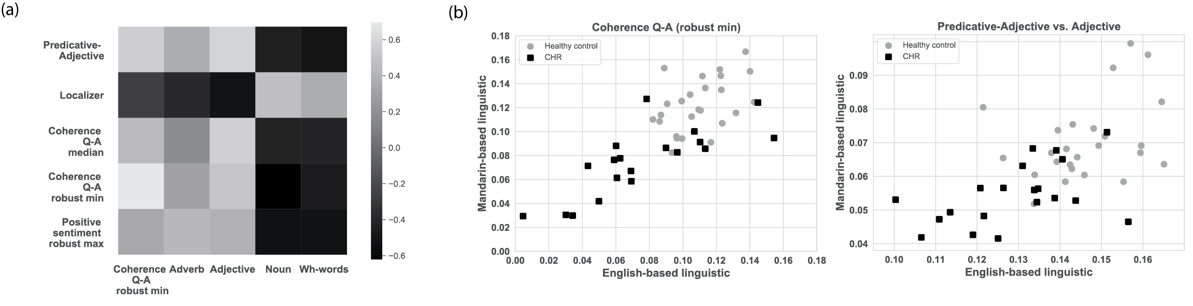
Supplementary Figure 3 Comparison between relevant features of English-based and Mandarin-based linguistic features. a) Heatmap of the correlation between both types of features, b) Comparison between both types of features of coherence Q-A (robust minimum), and c) Comparison between predicative-adjective and adjective.
Inference of SIPS/SOPS positive and negative symptom scores.
Only acoustic features were able to infer SIPS/SOPS scores with high performance (negative symptoms: r= 0.69, p=8E-4, positive symptoms: r=0.49, p=3E-2). Using linguistic features, the achieved performances were low (r<0.1) except for Mandarin-based linguistic features. These features can infer negative symptoms with r=0.36; however, given the small cohort, the results are not statistically significant (p=1E-1). When we analyzed the relevant features in the acoustic models, we found that degree of voice break and standard deviation (std) of the period are the most relevant features to infer positive symptoms. A statistical test reveals that these features have correlations of r=0.75 (p=1E-4) and r=0.60 (p=5E-3). On the other hand, the most relevant features for negative symptoms are related to MFCC coefficients #1 (r=-0.67, p=1E-3) and #8 (r=0.61, p=4E-3). Lastly, although the model to infer negative symptoms using Mandarin-based linguistic features did not achieve statistical significance, we found that the robust minimum of the second order coherence among answers, one of the extracted features, has a correlation of r=0.59, p=7E-3 with these symptoms.
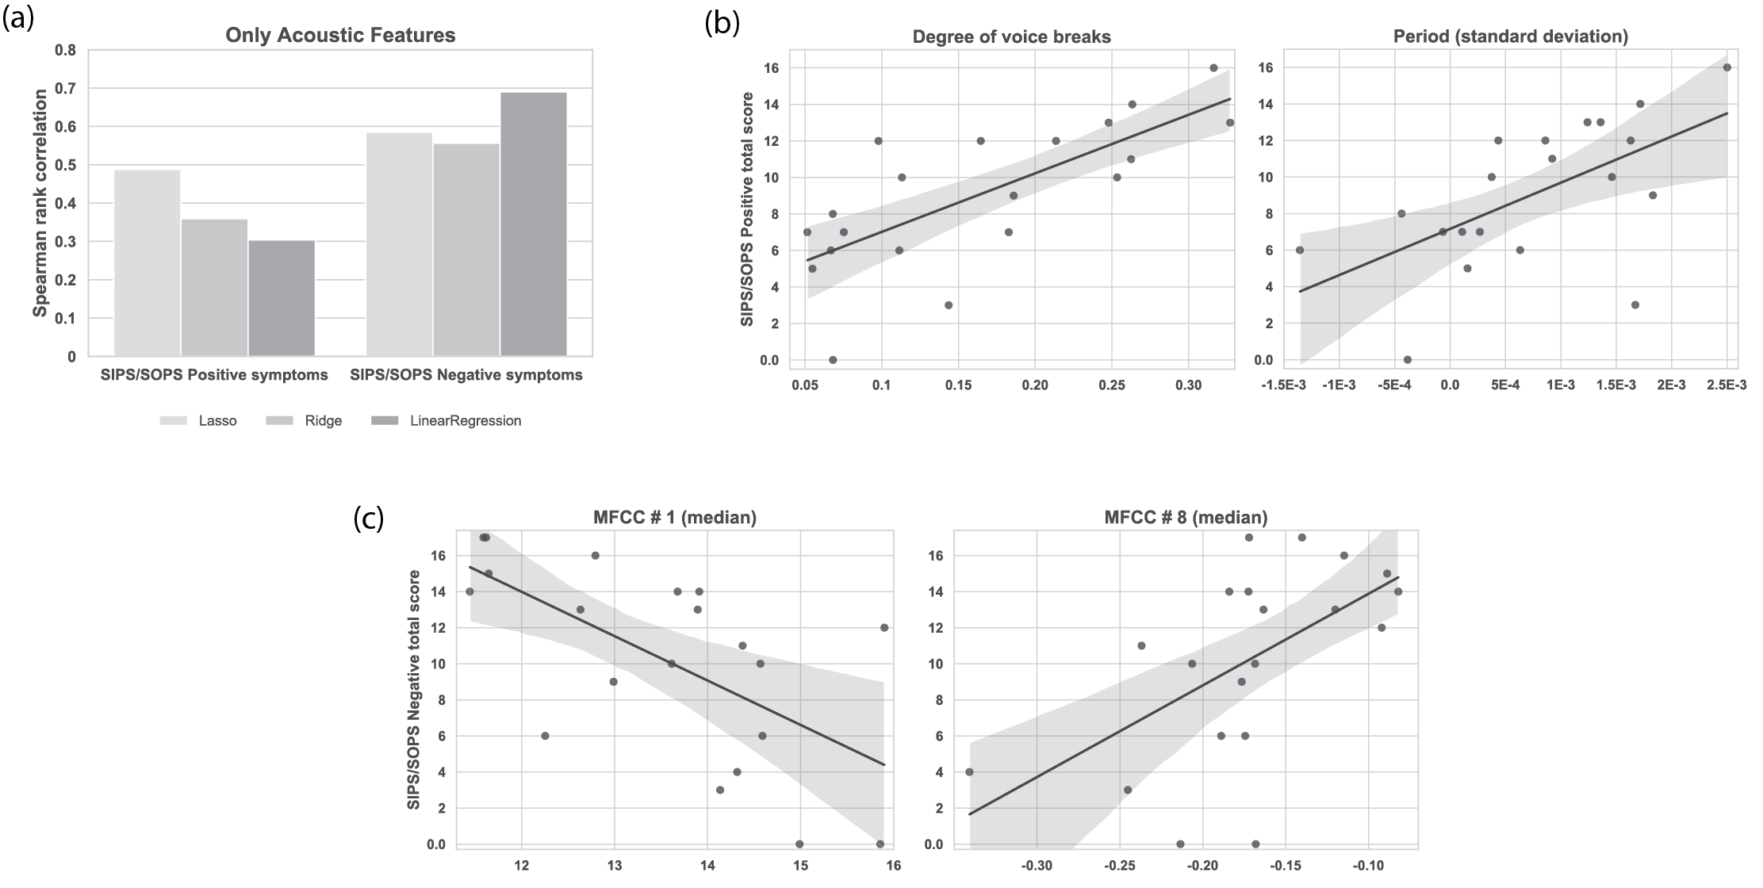
Supplementary Figure 4 Regression results for acoustic features. a) Performance of the cross-validated models using 3 different machine learning algorithms. b) Relevant features to infer positive symptoms score used in the best model (Lasso). Note that features were corrected by age and education years so values are also shifted to negative values. c) Top features to infer negative symptoms used in the best model (Linear Regression).

References:

1. Bernardini, F. et al. Associations of acoustically measured tongue/jaw movements and portion of time speaking with negative symptom severity in patients with schizophrenia in Italy and the United States. Psychiatry Res. 239, 253–258 (2016).
2. Covington, M. A. et al. Phonetic measures of reduced tongue movement correlate with negative symptom severity in hospitalized patients with first-episode schizophrenia-spectrum disorders. Schizophr. Res. 142, 93–95 (2012).
3. Zhang, J., Pan Z., Gui, C., Zhu, J. & Cui, D. Clinical investigation of speech signal features among patients with schizophrenia. Shanghai Arch. Psychiatry 28, 95–102.
4. Agurto, C. et al. Analyzing acoustic and prosodic fluctuations in free speech to predict psychosis onset in high-risk youths. in 2020 42nd Annual International Conference of the IEEE Engineering in Medicine & Biology Society (EMBC) 5575–5579 (IEEE, 2020).
5. Praat Vocal Toolkit: Cut pauses. http://www.praatvocaltoolkit.com/cut-pauses.html.
6. Giannakopoulos, T. pyAudioAnalysis: An Open-Source Python Library for Audio Signal Analysis. PLOS ONE 10, e0144610 (2015).
7. NLTK :: Natural Language Toolkit. https://www.nltk.org/.
8. Santorini, B. Part-of-Speech Tagging Guidelines for the Penn Treebank Project (3rd Revision). 37 (1990).
9. Mota, N. B. et al. Speech graphs provide a quantitative measure of thought disorder in psychosis. PloS One 7, e34928 (2012).
10. Cer, D. et al. Universal Sentence Encoder. ArXiv180311175 Cs (2018).
11. IBM Watson Natural Language Understanding - Features. https://www.ibm.com/cloud/watson-natural-language-understanding/details (2021).
12. mtl — HanLP Documentation. https://hanlp.hankcs.com/docs/api/hanlp/pretrained/mtl.html.
13. Xia, F. The Part-Of-Speech Tagging Guidelines for the Penn Chinese Treebank (3.0). IRCS Tech. Rep. Ser. (2000).
14. Pretrained Models — Sentence-Transformers documentation. https://www.sbert.net/docs/pretrained_models.html#multi-lingual-models.

